GLOBAL INTERDEPENDENCE

BIG QUESTIONS:
How are we connected with each other?
What are the challenges and benefits of cultural diversity?
How do cultural values and beliefs influence people’s lives?
How does immigration affect people’s lives?
How are we affected by cultural change?
How does diversity contribute to global interdependence?
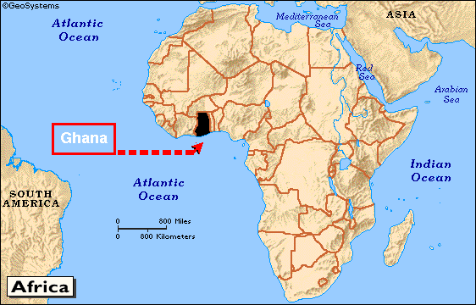
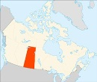
Where we live affects the __________ we eat, the __________ we wear, the ___________ we need, how we __________ and the ___________ we play. Living in Saskatchewan is very _____________ to living in a country like Ghana, and so our lives are very different. Where we live also affects our ___________ and what we think is important (our ____________). For example, if you were very poor, you might think food is more valuable than if you always had a lot of food.
We can use maps to give us a lot of _______________ . Some tell us about climate, others about the ________________ of a place (hills, rivers, etc), others can tell us about religions or different kinds of farming. Knowing about different countries’ geography and climate is important because it __________ us! Our ___________ comes from different places, we might want to ____________ there, it helps us understand why people live the way they do, and understand what people __________ and _______ they live.
When we look at a _______, we can make some guesses about what people’s lives are like based on the geography. For example, if people live in a very arid region, we can guess that farming would be very _______________.
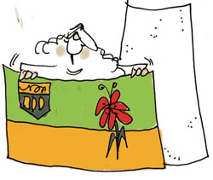
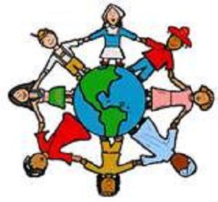
Culture is a _________________ way of living, including ____________ , ____________, ___________, __________ and __________, that are shared by a group of people. All people have the same basic _________, such as food, water, clothing, and shelter, but different cultures respond to their needs and wants in different ways. These are learned within families and communities, and also from media, school and different groups. Cultures can _____________ over time, and have both _____________ and _________________.
For example, introducing technology can improve people’s quality of life. Introducing new kinds of sugary food can change the lifestyle of people and damage their health. Culture can change as people ____________ from place to place and learn from each other. _________________ also allows cultures to spread as people can easily watch movies or tv from different cultures on the internet.
Saskatchewan is a ________________________ province. We celebrate the value of diverse cultures in Saskatchewan.
A _____________ is a group of people who have organized themselves to meet their basic ___________. A social structure is how people _____________ to each other. People have many different __________ within a society. A person could be a daughter, friend, sister, aunt, cousin, student, soccer player and expert yo-yo player all at once! A _________________ needs each person to do their role. They way societies function can change because of ______________ (for example, SK changed dramatically when European settlers moved here. The First Nation People’s lives changed as the buffalo were killed and their land was used for farmland.)
